Tarea #2 Week 1 Due: 2/4/2019
Plan an itinerary for a trip to Mexico.

- Read Cultura Viva (El Distrito Federal D.F)

- Decide what you want to see and do and indicate why each site or activity interests you (e.g., el Palacio Nacional – to see Diego Rivera’s artwork in person).
- Next, list hotels (with addresses and rates) where you want to stay. Include in your travel plans flight schedules to and from the destinations you want to visit, including Mexico City.
- Finally, map out your daily schedule from beginning to end.

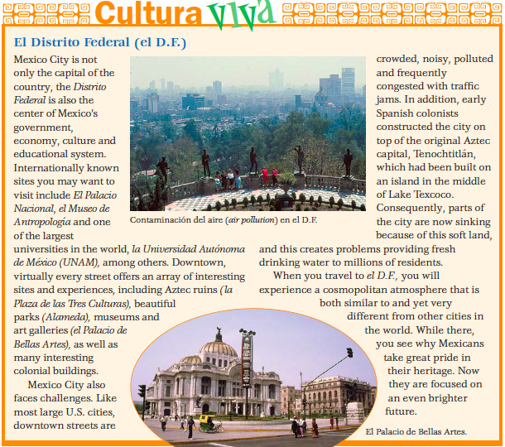

Ejemplo:
